Internship Report
Acknowledgements ......................................................................................................................1 Declaration ...................................................................................................................................2 Chapter 1 ..........................................................................................................................................3 Introduction ..................................................................................................................................3 Organization / Lab Profile ............................................................................................................3 Chapter 2 ..........................................................................................................................................4 PROJECT I: Transcriptome Analysis of Drosophila melanogaster S2 Cells Under Amino-Acid Starvation .........................................................................................................................................4 2.1. Introduction ...........................................................................................................................4 2.2. Objectives ..............................................................................................................................5 2.3. Materials and Methods ..........................................................................................................5 2.3.1. RNA-seq Dataset ................................................................................................................5 2.3.2. Quality Control Using Falco...........................................................................................6 2.3.3. Pre-processing of raw reads using Trimmomatic ...........................................................6 2.3.4. Reference Genome and Read Alignment using HISAT2 ...............................................7 2.3.5. Gene-Level Read Quantification ....................................................................................8 2.3.6. Differential Expression Analysis ....................................................................................9 2.3.7. Filtering of Differently Expressed Genes .....................................................................10 2.3.8. Gene Ontology Enrichment Analysis ...........................................................................10 2.3.9. KO (KEGG Orthology) Enrichment Analysis..............................................................11 2.3.10. Protein–Protein Interaction (PPI) Network Analysis Using STRING .......................11 2.3.11. Hub Gene Identification Using Cytoscape .................................................................11 2.4. Tools and Techniques Used ................................................................................................12 2.5. Results .................................................................................................................................12 2.5.1. Quality Control Results ................................................................................................13 2.5.2. Read Trimming and Filtering Results ..........................................................................14 2.5.3. Read Alignment Results ...............................................................................................14 2.5.4. Gene-Level Quantification Results ..............................................................................15 2.5.5. Differential Expression Analysis Results .....................................................................17 2.5.6. Gene Ontology Enrichment ..........................................................................................18 Biological Process ..................................................................................................................18
University of Agriculture, Faisalabad 1 of 44

Internship Report
Molecular Function .............................................................................................................19 Cellular Component ................................................................................................................19 2.5.7. KEGG Pathway Enrichment Results ............................................................................19 Significantly Enriched Pathways ........................................................................................20 2.5.8. Protein–Protein Interaction (PPI) Network Analysis ...................................................20 2.5.9. Hub Gene Identification ...............................................................................................21 2.6. Discussion ...........................................................................................................................22 2.7. Conclusion ...........................................................................................................................24 2.8. Limitations ..........................................................................................................................24 Chapter 3 ........................................................................................................................................24 PROJECT 2: Mutant-Specific Structure Prediction, Molecular Docking, and ADMET Profiling of Candidate Inhibitors Against Oncogenic KRAS G12D ............................................................25 3.1. Introduction .........................................................................................................................25 3.2. Objectives ............................................................................................................................25 3.3. Methodology .......................................................................................................................26 3.3.1 KRAS Structure Selection and Conformational Comparison .......................................26 3.3.2 Construction of the KRAS G12D Mutant .....................................................................26 3.3.3 Structural Validation of KRAS G12D ...........................................................................26 3.3.4 Selection of the Switch-II Pocket ..................................................................................26 3.3.5 Docking Grid Box Setup ...............................................................................................27 3.3.6 Ligand Preparation and Molecular Docking .................................................................27 3.3.7 Independent Docking Runs and Reproducibility Check ...............................................27 3.3.8 Interaction Analysis and Ligand Selection ....................................................................27 3.3.9 ADMET Profiling ..........................................................................................................28 3.4. Tools Used for Molecular Docking .....................................................................................28 3.5. Results .................................................................................................................................28 3.5.1. Conformational Comparison of KRAS Structures .......................................................29 3.5.2. G12D Mutant Construction Results ............................................................................29 3.5.3. Structural Validation Results ........................................................................................30 3.5.4. ERRAT and Verify3D Results .....................................................................................31 3.5.5. Docking ........................................................................................................................32
University of Agriculture, Faisalabad 2 of 44

Internship Report
3.5.6 Protein Ligand 3D Interaction Analysis ........................................................................32 3.5.7 ADMET Profiling ..........................................................................................................35 3.5.8 Final Candidate Selection ..............................................................................................36 3.6. Discussion ...........................................................................................................................37 3.7. Conclusion ...........................................................................................................................37 Chapter 4 ....................................................................................................................................37 4.1 Skills Gained ........................................................................................................................38 Computational and Analytical Skills ......................................................................................38 Research Skills .......................................................................................................................38 Data Handling and Interpretation ...........................................................................................38 Scientific Communication ......................................................................................................38 4.2 Summary ...........................................................................................................................39 4.3 Future Work ......................................................................................................................39 4.4. References .......................................................................................................................39
University of Agriculture, Faisalabad 3 of 44

Internship Report
Acknowledgements
First of all, I am thankful to Allah Almighty for giving me the strength and ability to complete my internship successfully. I would like to sincerely thank my supervisor, Sir Tahir-ul-Qamar, for his guidance, support, and valuable suggestions throughout my internship. His guidance helped me understand the different bioinformatics analyses and complete my work with better understanding.
I am also thankful to the Department of Bioinformatics, Government College University Faisalabad, for providing me with the opportunity to work in the laboratory and gain practical experience. I would also like to thank the lab staff for their cooperation, guidance, and help whenever I needed assistance during my work. Finally, I am grateful to my family and friends for their continuous support, encouragement, and motivation throughout my internship.
University of Agriculture, Faisalabad 4 of 44

Internship Report
Declaration
I, Mah Rukh Jamil, hereby declare that this internship report is based on the work carried out by me during my internship in the Bioinformatics laboratory at Government College University Faisalabad under the supervision of Sir Tahir-ul-Qamar. The work presented in this report includes the bioinformatics analyses and activities performed during my internship, particularly the molecular docking and transcriptomics projects.
I confirm that the information presented in this report has been written based on my
understanding and experience during the internship. The methods, tools, results, and
observations included in this report have been presented honestly and to the best of my knowledge. I have not intentionally included any false or misleading information in this report.
I take full responsibility for the content of this report and declare that, to the best of my knowledge, it represents my internship experience and the work performed during the assigned projects. Any external information or previously published material used in this report has been appropriately referenced.
University of Agriculture, Faisalabad 5 of 44

Internship Report
Chapter 1
Introduction
Bioinformatics is an interdisciplinary field that combines biology, computer science and data analysis to study and understand biological information. It helps researchers analyze large amounts of biological data using computational tools and databases. With the development of modern technologies, bioinformatics has become an important part of biological and biomedical research because it allows complex biological problems to be investigated through computational approaches.
During my internship, I applied bioinformatics approaches to two different research areas, molecular docking and transcriptomics. Molecular docking was used to investigate the interaction of potential ligands with the KRAS G12D mutant protein, while transcriptomics was used to analyze RNA-Seq data and study changes in gene expression of Drosophilla
Melanogaster under different conditions. These projects provided practical experience in applying computational methods to different types of biological problems.
Organization / Lab Profile
Government College University
Government College University (GCU) is a well-established educational and research institution in Pakistan. The university provides opportunities for students to gain both theoretical
knowledge and practical research experience in different scientific fields. Its research
environment supports the use of modern computational and experimental approaches for addressing biological and biomedical research problems.
Research Laboratory
During my internship, I worked in the research laboratory of Sir Tahir ul Qamar at Government College University. The laboratory provides an environment for bioinformatics and
computational research, where biological data are analyzed using different computational tools and approaches. The research work involves the application of bioinformatics methods to understand biological processes and investigate potential solutions to biomedical problems.
Internship Work
During the internship, I worked on two major bioinformatics projects. The first project involved structure-based molecular docking for the identification of potential inhibitors against the KRAS G12D mutant protein, followed by interaction analysis and ADMET profiling. The second project focused on transcriptomics, where RNA-Seq data from Drosophila melanogaster were
University of Agriculture, Faisalabad 6 of 44

Internship Report
analyzed to identify differentially expressed genes and their associated biological functions and pathways. These projects provided practical exposure to different bioinformatics tools, databases and computational analysis techniques.
Chapter 2
PROJECT I: Transcriptome Analysis of Drosophila melanogaster
S2 Cells Under Amino-Acid Starvation
2.1. Introduction
Transcripteomics is the study of transcriptomes which represents the collection of RNA transcripts produced by a cell, tissue or an organism. It provides information about gene expression under a particular condition. Since gene expression changes under different conditions so transcripteome helps researchers understand how a gene responds to specific biological condition.
RNA seq is a widely used technique for transcriptomic analysis. It measures the expression of many genes at the same time. The sample genes under different conditions are compared to identify the change in gene expression. These genes are known as differentially expressed genes (DEGs).
During my internship I performed RNA seq analysis using Galaxy which provides a wide range of tools for the analysis of sequencing data. The dataset of raw sequencing reads of two replicates under the normal and starved condition was downloaded from NCBI. The main goal was to identify the differentially expressed genes. So, the data was first filtered to remove any duplication or contamination. The reads were then aligned with the reference genome followed by the quantification of reads. The genes that were differently expressed in both conditions were identified using DESeq2. The resulting genes were further analyzed using Gene Ontology Enrichment and KEGG enrichment to identify the pathways and the biological, cellular, and molecular functions that were enriched among the significant DEGs.
2.2. Objectives
- To analyze RNA-Seq data from Drosophila melanogaster under normal and amino acid starvation conditions.
- To check the quality of the raw sequencing data before further analysis.
- To identify genes that show significant differences in expression between the two conditions using DESeq2.
- To understand the biological functions of the differentially expressed genes using GO enrichment analysis.
University of Agriculture, Faisalabad 7 of 44

Internship Report
- To identify the important pathways associated with the differentially expressed genes through KEGG enrichment analysis.
- To identify the interactions between the identified proteins and find important top 10 hub proteins using STRING and Cytoscape.
2.3. Materials and Methods
2.3.1. RNA-seq Dataset
Raw RNA-sequencing data for Drosophila melanogaster were obtained from the NCBI Sequence Read Archive (SRA) under study accession SRP242243. Four FASTQ datasets of two biological replicates under control and amino acid starved condition were selected.
Control: SRR10904051 and SRR10904052
Amino Acid Starvation: SRR10904053 and SRR10904054
The downloaded FASTQ files were used as the raw input for quality control, read trimming, and sequence alignment.
Table 1: Dataset Characteristics
Dataset Characteristic | Information

Organism | Drosophila melanogaster
Platform | Illumina
Instrument | NextSeq 500
Library layout | Single-end
Library selection | cDNA
Library source | Transcriptomic
SRA Study | SRP242243
Control samples | SRR10904051, SRR10904052
Amino Acid Starvation samples | SRR10904053, SRR10904054
2.3.2. Quality Control Using Falco
Quality control is the first step in any RNA-seq workflow, before performing alignment to ensure that only the high quality reads are used in analysis. Raw sequencing reads can contain low quality data and adapter contamination which is not good for the alignment accuracy and can lead to unreliable results in gene expression identification.
Falco was chosen to assess the quality of data over the more commonly used FastQC mainly for speed and efficiency. Falco performs same analysis as FASTQC but it is much faster than
University of Agriculture, Faisalabad 8 of 44

Internship Report
FASTQC and uses less memory, which matters the most when working with multiple large files. The quality of the raw FASTQ reads was assessed using Falco across all four RNA-seq samples (SRR10904051, SRR10904052, SRR10904053, and SRR10904054) to check the quality of raw data.
2.3.3. Pre-processing of raw reads using Trimmomatic
Although the Falco quality control report had already shown good per-base quality and clean adapter content, trimmomatic was applied as a precautionary step so if there is any remaining low quality bases, they will be removed and to further improve the quality of reads for a better alignment. In this way, it improves the overall reliability and reproducibility of the data.
Trimmomatic is a widely used tool for trimming and filtering raw sequencing reads generated by Illumina platforms. It removes low-quality bases, adapter sequences (illuminaclip), and reads that fall below a defined length. In this analysis, Trimmomatic was used to filter the raw FASTQ files (SRR10904051, SRR10904052, SRR10904053, SRR10904054).
Table 2: Trimmomatic Parameters
Parameter | Value

Read type | Single-end
Adapter removal (ILLUMINACLIP) | Not performed
Trimming method | SLIDINGWINDOW
Window size | 4 bases
Quality threshold | Q20
Quality encoding | Phred33
Alternative Tools and Justification for Using Trimmomatic
Other alternative tools for trimming include fastp, Cutadapt, and Sickle. fastp offers combined quality control and trimming. Cutadapt is mainly used for adapter specific trimming and has to combine with other tools for quality filtering, while Sickle performs only quality based trimming without having ability to remove adapters. Trimmomatic was chosen for this analysis because its parameters can be adjusted (e.g., sliding window size, quality threshold), which makes it a reliable and reproducible choice for this workflow.
2.3.4. Reference Genome and Read Alignment using HISAT2
Following the pre-processing, alignment was done using HISAT2. Alignment of reads to their corresponding genome is a crucial step because it determines the genomic location of reads. Alignment should be done accurately because poor alignment can lead to incorrect or incomplete mapping which produces biased or unreliable results.
University of Agriculture, Faisalabad 9 of 44

Internship Report
For this purpose, HISAT2 was used to align the filtered reads to the reference genome. HISAT2 is a fast, memory-efficient, splice-aware alignment tool designed specifically for RNA-Seq data. Unlike standard aligners, it can correctly align reads that span exon–exon junctions (reads from spliced mRNA), making it suitable for mapping transcriptomic reads to a reference genome.
The reference genome of Drosophila melanogaster(NCBI accession: GCF_000001215.4, RefSeq assembly) was downloaded from NCBI and then used as an input for HISAT2 along with the trimmomatic result file. HISAT2 was then used to align the trimmed reads to the reference genome, in order to determine the genomic origin of each read.
Table 3: HISAT2 Parameters Used
Parameter | Value

Reference genome source | History (uploaded genome)
Library type | Single-end
Strand information | Unstranded
Input, alignment, scoring options | Default
Spliced alignment options | Default
Reporting options | Default
Alternative Tools
HISAT2 was preferred in this study for its balance of speed, low memory requirement, and high mapping accuracy for splice-aware alignment. Other commonly used alignment tools for RNA-seq data include:
- STAR (Spliced Transcripts Alignment to a Reference) with high accuracy and speed but it requires more memory than HISAT2.
- TopHat2 is also an alignment tool but is slow and less accurate than HISAT2.
- Salmon is also used for alignment which offers faster processing but does not generate BAM files.
2.3.5. Gene-Level Read Quantification
After aligning the reads to their genome positions, the next step was to count the number of reads corresponding to each gene. Quantification is a crucial step in RNA seq analysis as it forms the basis of differential expressed genes.
Gene quantification was performed using the featureCounts tool in galaxy. This tool is used to quantify gene expression by counting the number of sequencing reads that align with the annotated genomic features, such as genes or exons. It takes BAM file of aligned reads from HISAT2 along with a gene annotation file as an input and produces a count matrix representing
University of Agriculture, Faisalabad 10 of 44

Internship Report
that how many reads were mapped to each gene in all the four samples. This count matrix is then used as an input file to determine the differentially expressed genes.
Table 4: featureCounts Parameters Used
Parameter | Value

Strand information | Unstranded
Annotation source | History (uploaded GFF)
Feature type | Exon
Gene identifier attribute | gene_id
Read type | Single-end
Minimum mapping quality | 0
Multi-mapping reads | Counted (exon-exon junctions allowed)
Minimum overlap | 1 base
Output format | Gene-ID + read-count (DESeq2/edgeR compatible)
Alternative Tools
featureCounts was preferred in this workflow for its better speed, simplicity. Other commonly used tools for gene-level quantification include
- HTSeq-count performs similar read counting but is slower than featureCounts on large datasets
- RSEM, which countsgene as well as isoform level expression but is more complex than featureCounts.
- Salmon is an alternative alignment tool as well as a gene quantification tool.
2.3.6. Differential Expression Analysis
After obtaining the gene count matrix, the next step was to identify the genes that showed a significant change in expression between the control and amino acid starvation conditions. This step helps to understand the biological impact of amino acid starvation.
DESeq2 within the galaxy was used for this purpose. DESeq2 is a widely used R/Bioconductor package for identifying differentially expressed genes from raw RNA seq count data. DESeq2 takes a gene level count matrix as input and performs steps such as normalization and dispersion estimationto determine which genes show significant changes in expression between
experimental conditions. The gene count matrix obtained from featureCounts was used as input for DESeq2.
Raw gene counts were used as input values for DESeq2 instead of already normalized values such as TPM/FPKM because DESeq2 performs its own internal normalization as part of its statistical model, which requires raw count data to function correctly. Since different samples
University of Agriculture, Faisalabad 11 of 44

Internship Report
can have different sequencing depths, DESeq2 performs normalization so that the genes can be compared fairly. It then performs the dispersion to measure the gene expression variation between biological replicates. Finally, genes that meet the selected padj (<0.05) and log2FC cutoffs are considered differentially expressed and are classified as either upregulated or downregulated.
Table 5: DESeq2 Parameters Used
Parameter | Value

Input data | Raw gene count matrix (from featureCounts)
Normalization method | Median-of-ratios (DESeq2 default)
Statistical test | Wald test
Comparison groups | Control vs. Amino Acid Starvation
Adjusted p-value (padj) cutoff | < 0.05
Log2 fold change cutoff | |log2FC| > 1
Multiple testing correction | Benjamini-Hochberg (BH) method
Alternative Tools
DESeq2 was chosen for this study because it is reliable, widely trusted, and commonly used in RNA-seq research. Other tools commonly used for differential expression analysis include
- edgeR works in a similar way to DESeq2, but it calculates change in expression between samples slightly different than DESeq2.
- limma-voom was originally designed for microarray data but can also be used to work with RNA seq data.
2.3.7. Filtering of Differently Expressed Genes
After doing the expression analysis, the DESeq results were filtered to obtain the upregulated genes using the Filter tool in Galaxy. A condition of genes with padj<0.05 and log2FoldChange >=1 was applied and a total of 560 upregulated genes were obtained and these genes were then used for further functional analysis.
2.3.8. Gene Ontology Enrichment Analysis
After identifying the upregulated genes from degs, GO enrichment analysis was performed to identify the biological functions associated with the upregulated genes. GO enrichment was performed using GOEnrichment tool in Galaxy. This tool works with the protein IDS of differentially expressed genes along with the go-basic.obo file and the protein annotation file of Drosophila Melanogaster.
University of Agriculture, Faisalabad 12 of 44

Internship Report
The functional annotation was performed by using eggNOG-mapper. The protein FASTA sequence was downloaded from NCBI and then uploaded on eggNOG-mapper. The resulting annotation file from eggNOG-mapper contained the protein ids along with the GO term and KO (KEGG Orthology) identifiers. The annotation file was then filtered to remove the protein IDS that did not have the GO or KO annotations.
The go-basic.obo file was downloaded from the official website of Gene Ontology.Ater this the gene IDS of differentially expressed genes were converted into protein ids by using R studio and then all the three files (go-basic.obo as the database file, annotation file with protein ids and corresponding GO terms, and protein IDS of upregulated genes file as a study set file) were uploaded on GO enrichment tool.
The GO enrichment tool compares the study set file with the background gene set to identify the GO terms that were overrepresented among the degs.
Table 6: GOEnrichment Parameters Used
Parameter | Value

Multiple Test Correction | Benjamini-Hochberg
P-Value Cut-Off | 0.01
The GOEnrichment terms were classified into three main categories:
•Biological Process (BP) describes the biolohical processes in which the DEGs were involved.
•Molecular Function (MF) describes the biological functions performed by the DEGs. •Cellular Component (CC) describes the location of DEGs in cell.
2.3.9. KO (KEGG Orthology) Enrichment Analysis
The differentially expressed genes were further used for KEGG pathway enrichment.The KO identofiers froms the annotated file for the upregulated genes wereselected and processed in
The study set containing the protein IDS of 562 upregulated genes were loaded in R along with the background annotation file and then converted the protein IDS of study set into the KO ids.
KEGG Enrichment was done using clusterProfiler (R package) in R to check which biological pathways were overly represented among the differentially expressed genes. Resulting p values were adjusted for multiple testing using Benjamini-Hochberg (BH) to remove the false positives and pvalueCutoff = 0.05 aur qvalueCutoff = 0.2 were applied on the data to identify the significantly enriched pathways.
University of Agriculture, Faisalabad 13 of 44

Internship Report
2.3.10. Protein–Protein Interaction (PPI) Network Analysis Using STRING
The differentially expressed genes were further analyzed to determine the protein-protein interactions among the proteins. For this purpose, the protein IDS of DEGs were uploaded on the official STRING website and the organism was selected as Drosophila melanogaster. An interaction score of 0.700 was applied to obtain high-confidence interactions. STRING gives the known and predicted interactions among the proteins based on available evidence like experimental data.
2.3.11. Hub Gene Identification Using Cytoscape
The PPI network obtained from STRING was further analyzed using Cytoscape to identify the hub genes. The string network was imported in Cytoscape and cytohubba plugin was used to identify the central proteins that showed thehighest number of interactions with other proteins. These genes were ranked according to their connectivity and the proteins with top interactions were selected as hub genes.
Hub genes are important because they have a large number of interactions with other proteins and these interactions show that they may have an important role in biological processes. However, the high connectivity with other proteins does not confirm that the protein is the most important, so the hub genes require further experimental validation.
2.4. Tools and Techniques Used
Table 7: Tools used in RNA seq analysis
Tool / | Purpose

Technique

NCBI | Raw RNA-Seq sequencing data ko obtain karne ke liye use kiya gaya.
Galaxy | RNA-Seq data ki quality control, preprocessing, alignment, quantification aur downstream analysis ke liye use kiya gaya.
FastQC / Falco | Raw sequencing reads ki quality assess karne ke liye use kiya gaya.
Reference Genome | Drosophila melanogaster ke reads ko reference genome ke against align karne ke liye use kiya gaya.
Read  Alignment | Sequencing reads ko reference genome ke corresponding regions ke saath match karne ke liye perform kiya gaya.
Read  Quantification | Har gene ke corresponding reads ki number determine karne ke liye use kiya gaya.
DESeq2 | Normal aur amino-acid starvation conditions ke darmiyan differentially expressed genes identify karne ke liye use kiya gaya.
Gene Ontology (GO)  Enrichment | Differentially expressed genes ke biological processes, molecular functions aur cellular components ko understand karne ke liye use kiya gaya.
KEGG  Enrichment Analysis | Differentially expressed genes se associated significantly enriched biological pathways identify karne ke liye use kiya gaya.
University of Agriculture, Faisalabad 14 of 44

Internship Report
STRING | Protein–protein interaction network construct karne aur proteins ke functional associations study karne ke liye use kiya gaya.
Cytoscape | STRING se obtained interaction network ko visualize aur analyze karne ke liye use kiya gaya.
cytoHubba | Protein–protein interaction network mein important hub proteins identify karne ke liye use kiya gaya.
2.5. Results
2.5.1. Quality Control Results
The results obtained from Falco were examined to identify the quality issues in the raw sequencing data.The results are summarized in Table 2.
Table 8. Quality control results of raw FASTQ reads assessed using Falco.
Quality Metric | Result

Basic Statistics | Pass
Per Base Sequence Quality | Pass
Per Sequence Quality Scores | Pass
Per Base Sequence Content | Fail
Per Sequence GC Content | Warn
Per Base N Content | Pass
Sequence Length Distribution | Warn
Sequence Duplication Levels | Fail
Overrepresented Sequences | Warn
Adapter Content | Pass
The same Pass, Warn, and Fail results were observed across all four samples of data.
Overall, raw data showed satisfactory per base and per sequence quality and there was no adapter contamintion also. However fail and warn results were observed for other factors which were considered during the preprocessing step using trimmomatic.
University of Agriculture, Faisalabad 15 of 44

Internship Report
Per base sequence quality Graph
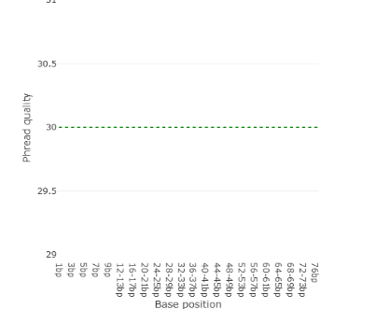
Figure 1 : Per-base sequence quality scores across read positions generated by Falco, showing consistently high Phred quality scores (Q30+) throughout the read length.
2.5.2. Read Trimming and Filtering Results
The raw reads were trimmed using trimmomatic and gives four trimmed files as a result.
Table 9: Trimmomatic Parameters
Parameter | Value

Read type | Single-end
Adapter removal (ILLUMINACLIP) | Not performed
Trimming method | SLIDINGWINDOW
Window size | 4 bases
Quality threshold | Q20
Quality encoding | Phred33
University of Agriculture, Faisalabad 16 of 44

Internship Report
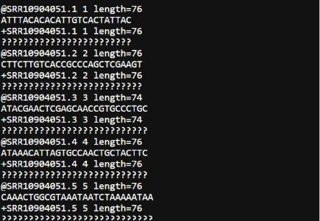
Figure 2: Showing output of trimmomatic
2.5.3. Read Alignment Results
The trimmed reads from trimmomatic were aligned byusing the HISAT2 tool which takes the
trimmed files and the genome of organism as an input.
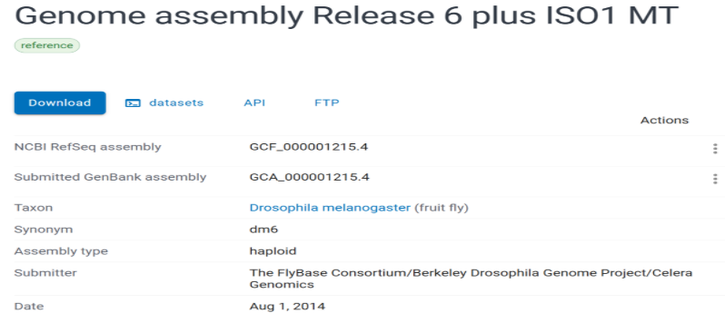
Figure 3: Reference Genome was downloaded from NCBI
University of Agriculture, Faisalabad 17 of 44

Internship Report
Alignment Summary
Alignment summary of HISAT gives statistics for all four samples.
SRR10904051(control) SRR10904052 (control)

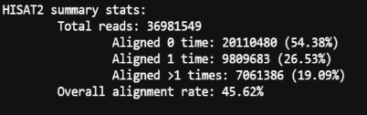

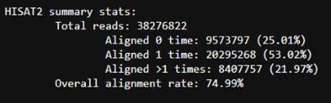

SRR10904053 (amino acid starvation) SRR10904054 (amino acid starvation)

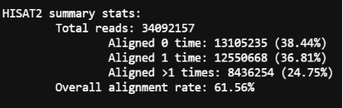

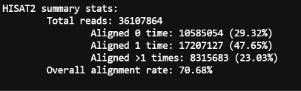

Figure 4: Alignment summary statistics from HISAT2
2.5.4. Gene-Level Quantification Results
featureCounts was run separately on each of the four aligned BAM files, producing an individual count file for each sample. The results of 10 genes were then
summarized in a table to show the difference in the read counts among the same genes in all four samples. Due to which some of the genes were highly expressed while other genes were less or not expressed. (Table6).
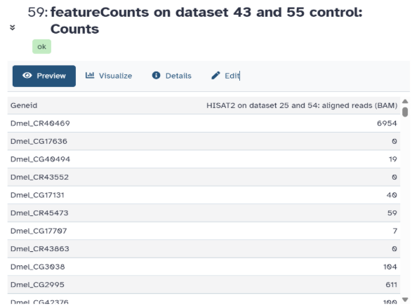
Figure 5: Output data of SRR10904051(control)
University of Agriculture, Faisalabad 18 of 44

Internship Report
Table 10: Combined featureCounts Output (Sample Genes, All 4 Samples)
Gene ID | SRR10904051(control) | SRR10904052 | SRR10904053 | SRR10904054
Gene ID | SRR10904051(control) | (control) | (amino acid | (amino acid
Gene ID | SRR10904051(control) | (control) | starvation) | starvation)

Dmel_CR40469 | 6954 | 39350 | 7666 | 14994
Dmel_CG17636 | 0 | 0 | 0 | 0
Dmel_CG40494 | 19 | 36 | 20 | 24
Dmel_CR43552 | 0 | 0 | 0 | 0
Dmel_CG17131 | 40 | 83 | 29 | 40
Dmel_CR45473 | 59 | 213 | 35 | 68
Dmel_CG17707 | 7 | 47 | 16 | 13
Dmel_CR43863 | 0 | 3 | 0 | 2
Dmel_CG3038 | 104 | 196 | 65 | 68
Dmel_CG2995 | 611 | 1111 | 537 | 671
Table 11: featureCounts Summary Statistics
Status | SRR10904051(contr | SRR109040 | SRR109040 | SRR109040
Status | SRR10904051(contr | 52 (control) | 53 (amino | 54 (amino
Status | ol) | 52 (control) | acid | acid
Status | ol) | 52 (control) | starvation) | starvation)

Assigned | 8,689,945 | 18,276,354 | 11,065,292 | 15,382,924
Unassigned_Unmapped | 20,110,480 | 9,573,797 | 13,105,235 | 10,585,054
Unassigned_MultiMapp ing | 32,111,776 | 36,755,023 | 38,783,757 | 36,595,362
Unassigned_NoFeatures | 642,652 | 1,156,596 | 856,457 | 1,149,212
Unassigned_Ambiguity | 477,086 | 862,318 | 628,919 | 674,991
Unassigned_Read_Type / Singleton /  MappingQuality /  Chimera /  FragmentLength /  Duplicate / Secondary / NonSplit /  Overlapping_Length | 0 (all) | 0 (all) | 0 (all) | 0 (all)
2.5.5. Differential Expression Analysis Results
The files from featureCounts were uploaded on DESeq2 and it produces different graphs as a
result.
Principal Component Analysis (PCA)
University of Agriculture, Faisalabad 19 of 44

Internship Report
PCA was used to see the overall variation among the samples and to check whether the samples from the same condition showed similar expression patterns. The PCA plot showed the distribution of the Control and Amino Acid Starvation samples based on their overall gene expression. Samples belonging to the same condition were expected to cluster together, while separation between the two groups indicated differences in their overall expression profiles.
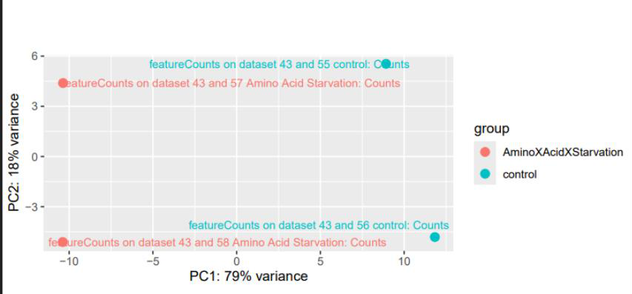
Figure 6. PCA plot of the four RNA-Seq samples, showing clear separation between Control and Amino Acid Starvation groups along PC1.
MA-Plot
The MA-plot (Figure 9) shows the relationship between mean expression and log fold change for each gene, with statistically significant genes highlighted in blue. A large number of genes were found to be both upregulated and downregulated under starvation conditions, indicating a transcriptional response to amino acid starvation.
University of Agriculture, Faisalabad 20 of 44

Internship Report
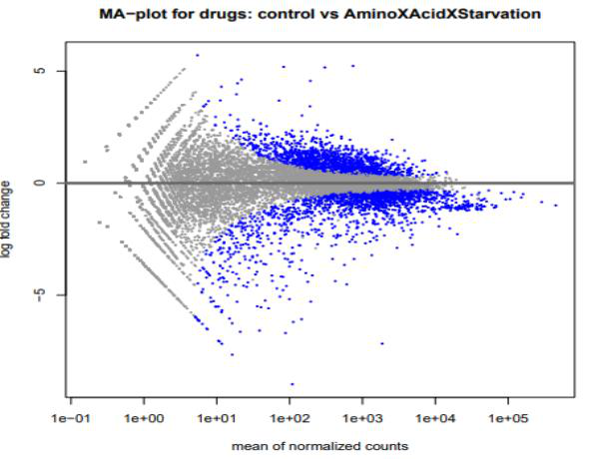
Figure 7. MA-plot showing log fold change versus mean expression for Control vs Amino Acid Starvation, with significant genes (padj < 0.05) shown in blue.
2.5.6. Gene Ontology Enrichment
GO enrichment was performed on upregulated genes to identify the biological, molecular and cellular processes in which the upregulated genes were involved.
Biological Process
The enriched biological processes were mainly related to mitochondrial functions, including mitochondrion organization, sperm mitochondrion organization, and mitochondrial translation.
Other enriched processes were related to cell division and meiosis, such as cell division, organelle fission, meiotic cell cycle checkpoint signaling, and fusion of sperm to egg plasma membrane.
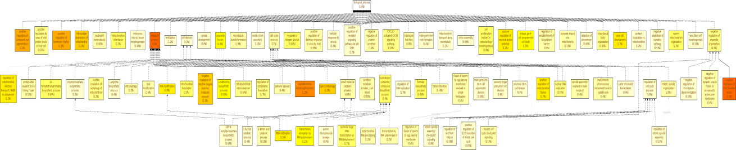
Figure 8. GO enrichment analysis of upregulated genes showing enriched terms in biological process.
University of Agriculture, Faisalabad 21 of 44

Internship Report
Molecular Function
The enriched molecular functions were mainly related to catalytic activities. These included catalytic activity acting on a nucleic acid, DNA-directed RNA polymerase activity, RNA methyltransferase activity, and histone H4K/H4K8 deacetylase activity.
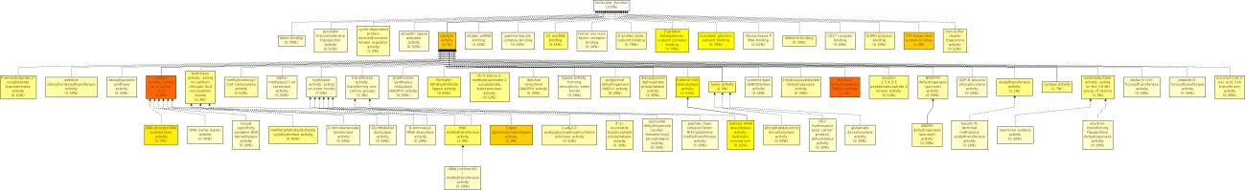
Figure 9. GO enrichment analysis of upregulated genes showing enriched terms in Biological Process, Molecular Function, and Cellular Component categories.
Cellular Component
The GO analysis showed that many of the upregulated genes were associated with mitochondria.
The main enriched terms included mitochondrion (15%), mitochondrial membrane (8.5%), mitochondrial matrix (5.8%), and mitochondrial outer membrane (3.8%). Other enriched cellular components included the germline-specific structure Nebenkern (1.5%) and the DNA-directed RNA polymerase complex (2.0%).
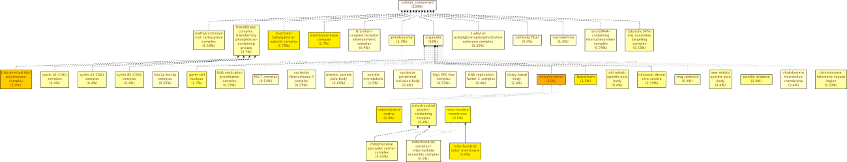
Figure 10. GO enrichment analysis of upregulated genes showing enriched terms in cellular component categories.
2.5.7. KEGG Pathway Enrichment Results
KEGG Enrichment was done using R programming to identify the biological pathways that were overrepresented within the upregulated genes.
Significantly Enriched Pathways
KEGG pathway enrichment analysis identified nine significantly enriched pathways among the upregulated genes (Figure X). The Motor proteins pathway showed the highest enrichment, with approximately 25 genes and a p.adjust value of around 0.01. DNA replication and RNA polymerase were also enriched, with around 10–11 genes involved in each pathway. The Cell
University of Agriculture, Faisalabad 22 of 44

Internship Report
cycle pathway had 16 genes. Other significantly enriched pathways included Oocyte meiosis, progesterone-mediated oocyte maturation, p53 signaling pathway, cytosolic DNA-sensing pathway and beta-Alanine metabolism, with around 6–11 genes involved in these pathways.
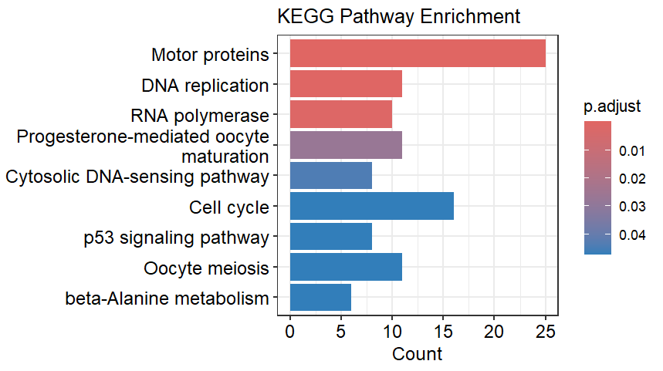
Figure 11. KEGG pathway enrichment analysis of upregulated genes showing the significantly enriched pathways and the number of genes associated with each pathway.
2.5.8. Protein–Protein Interaction (PPI) Network Analysis
The STRING analysis generated a PPI network containing 464 proteins and 1832 interactions.
A minimum interaction score of 0.700 was used to retain high confidence interactions. The interaction scores ranged from 0.700 to 0.999, with an average score of 0.8603, indicating that the network mainly consisted of high-confidence protein interactions.
University of Agriculture, Faisalabad 23 of 44

Internship Report
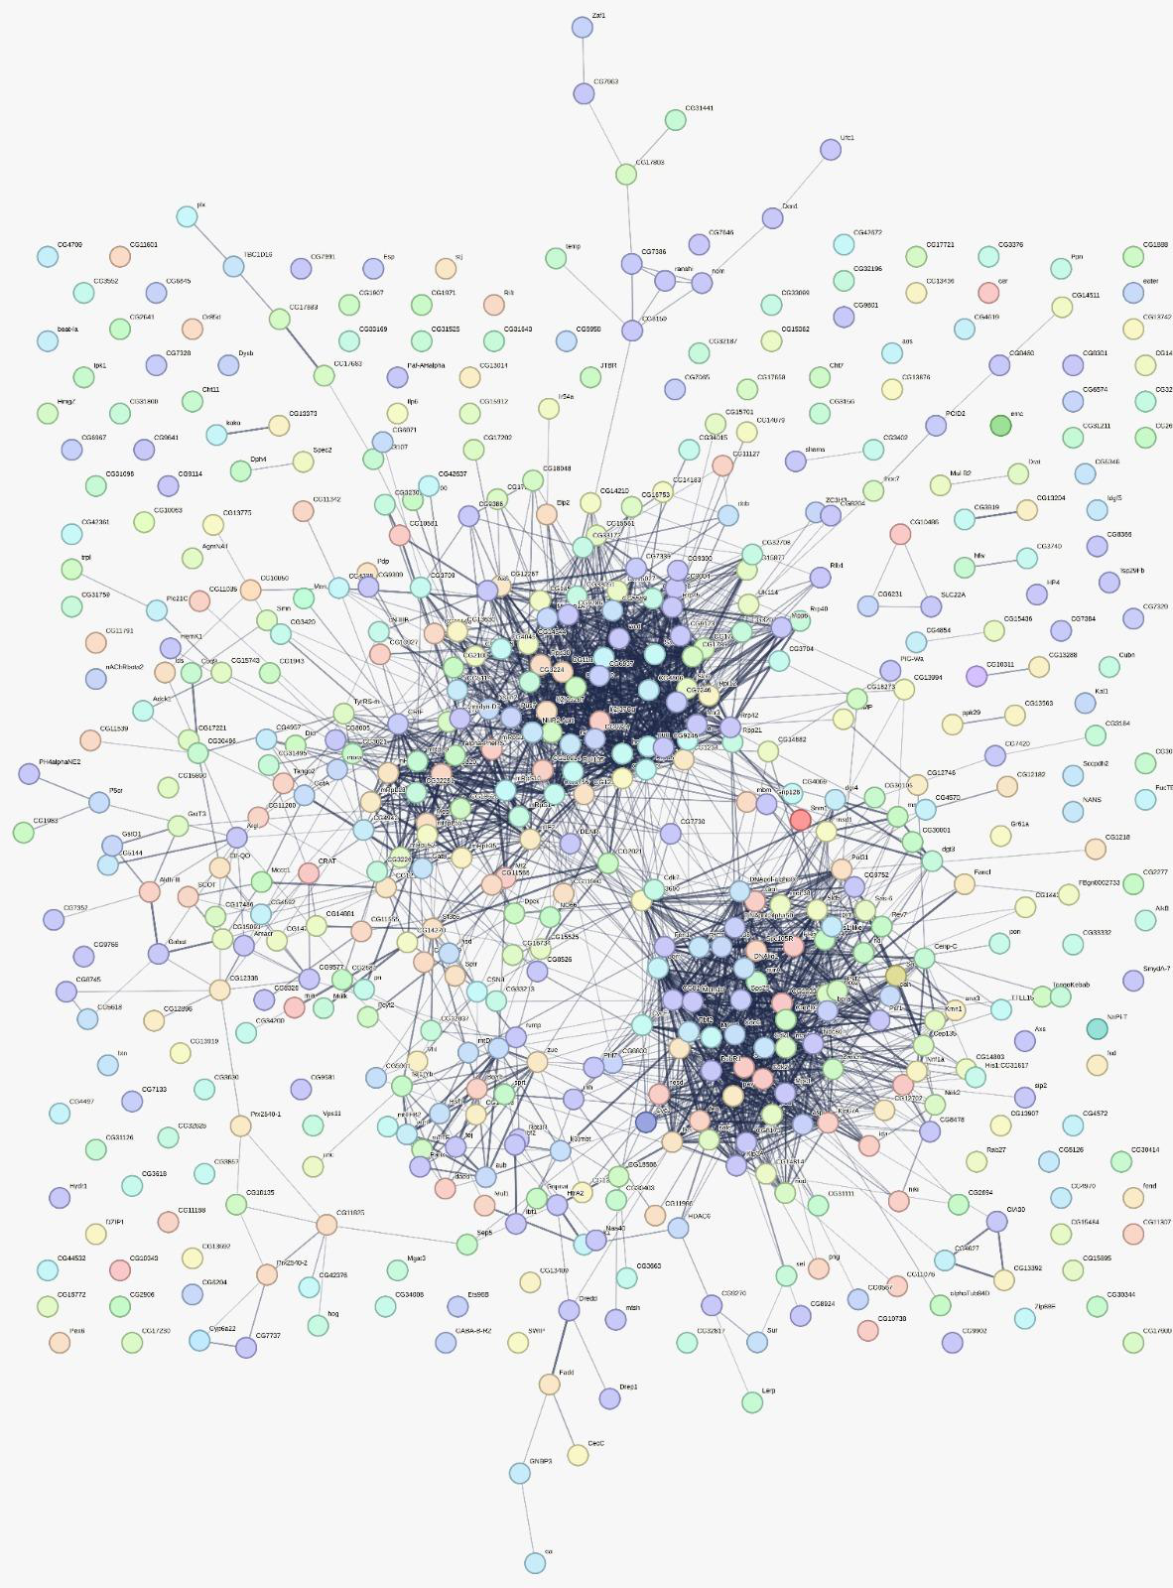
Figure 12. Protein–protein interaction network of the upregulated proteins generated using STRING with a minimum interaction score of 0.700.
2.5.9. Hub Gene Identification
The STRING interaction network was further analyzed in Cytoscape using the CytoHubba plugin to identify the most highly connected proteins. The Maximum Clique Centrality (MCC) method was used to rank the proteins according to their network connectivity. The top 10 proteins were selected as hub genes. CG11837 ranked first with an MCC score of 1.01 × 10⁷.
Other top hubgenes are shown in the table below:
University of Agriculture, Faisalabad 24 of 44

Internship Report
Table 11: top 10 hubgenes
Rank | Hub gene | MCC score

1 | CG11837 | 10,120,486
2 | CG7246 | 9,825,272
3 | wcd | 9,753,254
4 | CG1789 | 9,035,314
5 | CG6937 | 6,406,504
6 | Sas10 | 6,307,944
7 | NHP2 | 6,302,701
8 | CG9246 | 6,056,887
9 | l(2)05287 | 5,733,216
10 | CG4806 | 5,249,736
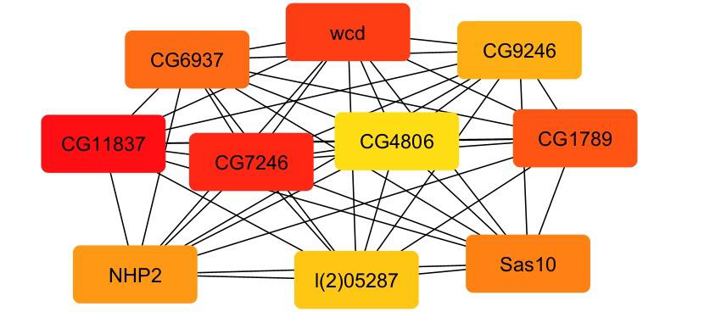
Figure 13. Top 10 hub proteins identified from the STRING PPI network using the MCC method in CytoHubba.
2.6. Discussion
Differential Expression Analysis
The differential expression analysis showed that amino acid starvation caused changes in gene expression compared with the control condition. A number of genes showed increased
expression under the starvation condition, indicating that the cells responded to the lack of amino acids. These changes suggest that the cells may activate different mechanisms to adjust to the change in nutrient availability so that they can survive. The upregulated genes were therefore
University of Agriculture, Faisalabad 25 of 44

Internship Report
selected for further analysis to understand the biological processes and pathways involved in this response.
Gene Ontology Enrichment Analysis
The GO enrichment results showed that many of the upregulated genes were associated with mitochondrial components and functions. Several enriched terms were related to the
mitochondrion, mitochondrial membrane, mitochondrial matrix, and mitochondrial organization.
This may indicate that amino acid starvation affects mitochondrial activity and related cellular functions. Since mitochondria are involved in energy production and metabolism, changes in mitochondrial-related genes may help cells adjust to limited nutrient availability. Other enriched terms related to cell division and meiotic processes also suggest that starvation may influence growth of and reproductive functions.
KEGG Pathway Enrichment Analysis
The KEGG analysis showed enrichment of pathways involved in different cellular and metabolic activities. Pathways such as DNA replication, RNA polymerase, cell cycle, p53 signaling, and cytosolic DNA sensing were among the enriched pathways. The enrichment of DNA replication and cell cycle pathways may indicate changes in cellular growth and division under amino acid starvation. Similarly, the involvement of the p53 signaling pathway may be related to the cellular response to stress. The enrichment of beta Alanine metabolism also suggests that amino acid starvation may affect metabolic processes as the cells respond to changes in nutrient availability.
Overall, these findings indicate that the response to amino acid starvation involves several cellular pathways rather than only one specific process.
Protein–Protein Interaction Network Analysis
The STRING analysis showed that many of the proteins associated with the upregulated genes were connected with each other. The network contained 464 proteins and 1,832 interactions at a high-confidence interaction score of 0.700. This indicates that the proteins may work together in different biological processes affected by amino acid starvation. Looking at the interactions between proteins provides additional information because changes in one gene may be related to other proteins involved in the same cellular functions. The PPI network therefore helped to identify groups of proteins that may be involved in the overall response.
Hub Gene Analysis
The hub gene analysis identified highly connected proteins within the PPI network using the MCC method in CytoHubba. The top-ranked proteins included CG11837, CG7246, wcd, CG1789, CG6937, Sas10, NHP2, CG9246, l(2)05287, and CG4806. These proteins showed high connectivity within the network, suggesting that they may have important roles in the
University of Agriculture, Faisalabad 26 of 44

Internship Report
interactions among the affected proteins. The hub genes can therefore be considered potential key proteins for further investigation. However, their high connectivity does not by itself prove that they are responsible for the starvation response, so further experimental studies would be needed to confirm their specific roles.
Overall Interpretation
Overall, the results show that amino acid starvation affects different cellular activities in Drosophila melanogaster. The GO analysis mainly showed changes related to mitochondrial functions, while the KEGG analysis highlighted pathways involved in metabolism, DNA replication, transcription, cell cycle, and stress response. The STRING analysis also showed that many of these proteins interact with each other, and the hub gene analysis helped identify some highly connected proteins. Overall, these results suggest that the cells respond to amino acid starvation by changing several metabolic and cellular processes at the same time.
2.7. Conclusion
In this study, RNA-Seq data was analyzed to see how amino acid starvation affects gene expression in Drosophila melanogaster. Differential expression analysis was used to find the genes that changed under starvation conditions. The upregulated genes were then analyzed using GO and KEGG enrichment analysis to understand their functions and pathways. The analysis showed that these genes were involved in different processes such as metabolism, mitochondrial functions, DNA replication, and cell cycle. STRING and Cytoscape were also used to study protein interactions and find important hub proteins. Overall, the results showed that amino acid starvation affects several cellular and metabolic processes in Drosophila melanogaster.
2.8. Limitations
One limitation of this study was that the analysis was based on available RNA-seq data and computational methods. The study included only a limited number of biological replicates (two), which may affect the reliability of some statistical results. The GO, KEGG, and PPI analyses were also based on available annotations and predicted or known interactions. Therefore, the identified pathways and hub genes provide useful information but would need further
experimental validation to confirm their biological roles.
University of Agriculture, Faisalabad 27 of 44

Internship Report
Chapter 3
PROJECT 2: Mutant-Specific Structure Prediction, Molecular Docking, and ADMET Profiling of Candidate Inhibitors Against Oncogenic KRAS G12D
3.1. Introduction
KRAS is signaling oncogene that is involved in cell growth and mutations in this gene can lead to cancer development. KRAS works like a switch and allows cell to grow when it is in its active state and returns to its inactive state when GTP is hydrolyzed to GDP and cell stops growing.
KRAS G12D mutation is caused by substitution of glycine with aspartate at 12 position which disturbs the normal functioning of cell and can lead to pancreatic cancer. This study aims to explore the therapeutic strategies that can be used against KRAS G12D mutation using structure-based computational methods.
In this project, first the KRAS structure in its GDP state was mutated in chimeraX and then mutated structure was validated using Ramachandaran plot, Verify 3D and ERRAT. The results were satisfactory and no steric clash was observed. Then molecular docking of 100 ligands was performed on switch -II region of mutated protein using PyRx in two independent docking runs to ensure the consistency of ligands with lowest binding energy. The resulting top ten ligands were visualized in PyMol. Ligands showeing consistent binding with switch-II region residues were selected while those with incosistent binding were excluded. Those who showed interaction with switch 2 region in both runs were selected for ADMET profiling. All ligands passed the ADMET prediction since no one showed AMES toxicity and were non-inhibitors of hERG1 and hERG2.
Overall, the study identified ligand 5321865 as a potential candidate due to its consistent binding and favorable ADMET results. But further experimental evidences are required to validate its inhibitory against KRAS G12D.
3.2. Objectives
The main objectives of this project were:
1.To compare GDP-bound and GTP-bound KRAS structures and select a suitable template. 2.To construct the KRAS G12D mutant structure using computational mutagenesis. 3.To validate the predicted mutant structure using structural quality assessment tools. 4.To identify the switch-II pocket as the docking site.
5.To perform molecular docking of candidate inhibitors against KRAS G12D.
University of Agriculture, Faisalabad 28 of 44

Internship Report
6.To compare two independent docking runs and identify common high-ranking ligands. 7.To analyze the interactions of selected ligands with the KRAS G12D binding pocket. 8.To evaluate the ADMET properties of the selected compounds.
3.3. Methodology
3.3.1 KRAS Structure Selection and Conformational Comparison
Two experimentally determined KRAS structures, 4OBE and 6VJJ, were selected to compare the GDP-bound and GTP-bound conformations. The structures were overlapped in PyMOL to examine differences in the overall structure and the switch-II region.
The overall backbone and switch-II regions were compared using RMSD to determine the conformational difference between the two states. Based on the structural comparison, the GDP-bound 4OBE structure was selected as the template for further mutant construction and docking.
3.3.2 Construction of the KRAS G12D Mutant
The G12D mutation was introduced into Chain A of 4OBE by replacing Gly12 with Asp12. The mutation was performed using the Rotamer tool in ChimeraX with the Dunbrack rotamer library.
Different rotamer conformations of Asp12 were examined, and a suitable rotamer was selected based on its position and fit within the surrounding structure.
3.3.3 Structural Validation of KRAS G12D
The constructed KRAS G12D model was validated to check its overall structural quality. MolProbity was used for Ramachandran analysis and geometry assessment. The P-loop region containing the mutated residue and the switch-II region were also examined separately.
ERRAT was used to assess non-bonded interactions, while Verify3D was used to check whether the residues were present in suitable three-dimensional environments.
3.3.4 Selection of the Switch-II Pocket
The switch-II pocket (SII-P) was selected as the target binding site for molecular docking. The pocket was selected because it is an important allosteric binding site for KRAS inhibitors and provides a suitable region for small-molecule binding.
University of Agriculture, Faisalabad 29 of 44

Internship Report
The reported switch-II pocket-lining residues were used as a reference for defining the docking region. These included Val9, Ala11, Asp12, Pro34, Thr58, Ala59, Gln61, Glu62, Tyr64, Arg68, Asp69, Met72, Asp92, His95, Tyr96, Gln99, Ile100, and Val103.
3.3.5 Docking Grid Box Setup
The docking grid box was positioned around the switch-II pocket using PyRx. The grid was made large enough to cover the selected pocket and allow the ligands to explore different binding orientations.
The docking grid was defined using the following parameters:
Table 12: Parameters of box
Parameter | Value

Center X | 1.6986 Å
Center Y | -19.8568 Å
Center Z | 55.9590 Å
Size X | 18.8373 Å
Size Y | 24.3331 Å
Size Z | 27.4444 Å
These parameters were kept the same for both independent docking runs.
3.3.6 Ligand Preparation and Molecular Docking
A total of 100 prepared ligands were selected for virtual screening against the KRAS G12D switch-II pocket. Molecular docking was performed using AutoDock Vina through the PyRx platform.
An exhaustiveness value of 8 was used, while the remaining docking parameters were kept at the default PyRx settings. The predicted binding affinity in kcal/mol was used as the initial measure for comparing ligand binding.
3.3.7 Independent Docking Runs and Reproducibility Check
To check the consistency of the docking results, all 100 ligands were docked in two
independent runs using the same docking parameters. The independent runs allowed comparison of the predicted binding affinities and binding poses obtained for the same ligands.
The difference between the binding affinities obtained from the two runs was also considered during ligand selection.
University of Agriculture, Faisalabad 30 of 44

Internship Report
3.3.8 Interaction Analysis and Ligand Selection
The high-ranking ligands from the docking runs were further examined in PyMOL to study their binding poses and residue-level interactions within the KRAS G12D pocket. Ligands showing favorable docking scores together with consistent switch-II interactions in both runs were retained for further analysis.
Ligands whose poses mainly involved the nearby P-loop region or showed inconsistent switch-II interactions between the two runs were excluded.
3.3.9 ADMET Profiling
The five final shortlisted ligands were evaluated for their ADMET properties to assess their predicted absorption, distribution, metabolism, and toxicity profiles. The analysis included water solubility, Caco-2 permeability, intestinal absorption, fraction unbound (Fu), blood-brain barrier (BBB) permeability, CYP enzyme interactions, total clearance, hERG inhibition, AMES toxicity, and hepatotoxicity.
The predicted ADMET properties were compared among the selected ligands to assess their absorption, distribution, metabolism, and toxicity profiles. Caco-2 permeability and intestinal absorption were also considered because KRAS is an intracellular target and the compounds need to enter cells to reach the target protein.
3.4. Tools Used for Molecular Docking
Table 13: tools used for docking
Tool / Technique | Application in the Project

ChimeraX | Used to introduce the G12D mutation into the GDP-bound KRAS structure and visualize the protein structure.
Ramachandran Plot | Used to evaluate the structural quality of the mutated KRAS protein by analyzing backbone dihedral angles.
Verify3D | Used to assess the compatibility of amino acid residues with their three-dimensional structural environment.
ERRAT | Used to evaluate the overall quality of the protein structure based on non-bonded interactions.
PyRx | Used to perform molecular docking of 100 candidate ligands against the Switch-II region of KRAS G12D.
AutoDock Vina | Used as the docking engine to estimate the binding affinity of the ligands.
PyMOL | Used to visualize docking poses and analyze interactions between selected ligands and KRAS G12D.
ADMET  Analysis | Used to evaluate the predicted pharmacokinetic and toxicity-related properties of selected ligands.
University of Agriculture, Faisalabad 31 of 44

Internship Report
3.5. Results
3.5.1. Conformational Comparison of KRAS Structures
The PyMOL overlay showed that the overall structures of GDP-bound 4OBE and GTP-bound 6VJJ were quite similar. However, a clear difference was observed in the switch-II region. The displacement at residue 60 was approximately 3.8 Å.
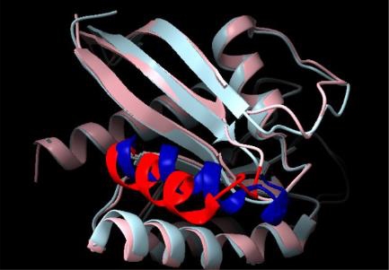
Figure 13: Overlay of GDP-bound KRAS (4OBE) and GTP-bound KRAS (6VJJ) showing the difference in the switch-II region.
Table 14. RMSD Comparison of KRAS Structures
Comparison | RMSD | Interpretation

Overall backbone | 0.769 Å | Overall structure remained largely unchanged
Switch-II region | 4.421 Å | 4.421 Å Significant local structural difference
Based on these results, the 4OBE GDP-bound structure was selected as the template for G12D mutant construction and docking.
3.5.2. G12D Mutant Construction Results
The G12D mutation was introduced by replacing Gly12 with Asp12 in Chain A of the 4OBE structure. Different rotamers were examined in ChimeraX, and a suitable Asp12 rotamer was selected.
University of Agriculture, Faisalabad 32 of 44

Internship Report
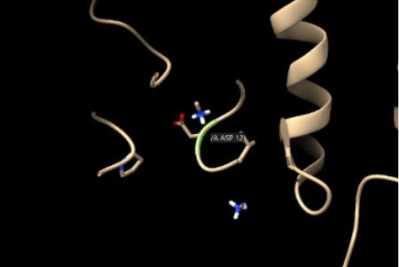
Figure 14: Close-up view of the mutant residue Asp12.
Glycine is a very small residue, while aspartate has a larger side chain. Therefore, some change in the local packing around the P-loop was expected. The tested rotamers showed distances of about 2.2–3.2 Å from nearby P-loop atoms, but no major steric clash was observed.
The selected rotamer placed the Asp12 side chain outward and allowed it to fit properly in the structure. The Cβ deviation of 0.07 Å also showed very little local structural change.
The mutation also introduced a negatively charged side chain at position 12, which changed the local charge environment around the nucleotide-binding region.
3.5.3. Structural Validation Results
The mutant structure was validated using MolProbity, ERRAT, and Verify3D. The
Ramachandran analysis showed that 98.81% of residues were in favored regions, while 0.00% were in disallowed regions.
University of Agriculture, Faisalabad 33 of 44

Internship Report
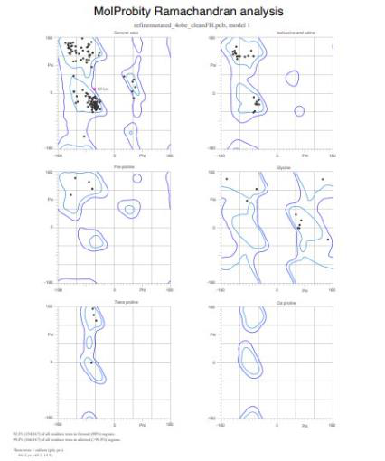
Figure 15: Ramachandran plot of the refined KRAS G12D mutant structure. Table 15. Structural Validation Results
Validation Method | Result | Interpretation

Ramachandran favored | 98.81% | 98.81% Good backbone geometry
Ramachandran disallowed | 0.00% | 0.00% No major backbone outliers
MolProbity score | 0.74 | 0.74 Good structural quality
Clashscore | 0.75 | 0.75 Very few steric clashes
ERRAT | 95.03 | 95.03 Good overall model quality
Verify3D | 86.98% | Passed structural environment check
The P-loop region was also examined because it contains the mutated residue Asp12. Asp12 showed favorable geometry with a Cβ deviation of 0.07 Å, indicating that the mutation did not cause major local structural changes.
The switch-II region (residues 60–76) was also checked because it contains the docking pocket.
No major structural outliers were observed in this region. A minor rotamer deviation was observed for Tyr71, but it was not considered a major structural problem since it was in allowed region.
3.5.4. ERRAT and Verify3D Results
The KRAS G12D model obtained an ERRAT score of 95.03, indicating good non-bonded interactions throughout the structure.
University of Agriculture, Faisalabad 34 of 44

Internship Report
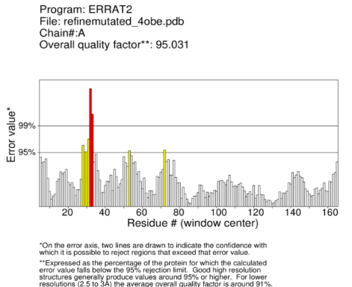
Figure 16: ERRAT analysis of the KRAS G12D mutant structure.
Verify3D showed that 86.98% of residues scored ≥0.1, and the model passed the validation. These results supported the use of the mutant structure for molecular docking.
3.5.5. Docking
Comparison of Independent Docking Runs
The 100 ligands were docked in two independent runs, and the predicted binding affinities from both runs were compared. Several ligands appeared among the high-ranking compounds in both runs, with only small differences in their predicted binding affinities.
Table 16. Common High-Ranking Ligands from Both Docking Runs
Ligand | Run 1 (kcal/mol) | Run 2 (kcal/mol) | ΔAffinity

MPD3_00160 | -8.5 | -8.5 | 0.0
MPD3_01685 | -8.2 | -8.3 | 0.1
MPD3_01673 | -8.1 | -8.0 | 0.1
MPD3_00632 | -8.0 | -7.9 | 0.1
MPD3_00811 | -7.9 | -7.9 | 0.0
MPD3_01369 | -7.9 | -7.9 | 0.0
MPD3_00165 | -7.8 | -7.8 | 0.0
MPD3_00765 | -7.8 | -7.9 | 0.1
MPD3_00948 | -7.8 | -7.9 | 0.1
MPD3_00627 | -7.8 | -7.7 | 0.1
The docking scores were highly similar between the two runs, with differences of only 0.0–0.1 kcal/mol for the common high-ranking ligands. This showed good consistency between the independent docking runs.
University of Agriculture, Faisalabad 35 of 44

Internship Report
3.5.6 Protein Ligand 3D Interaction Analysis
The selected ligand was examined to identify its interactions with residues in the KRAS G12D switch-II pocket.
Ligand 5281801
Run 1: Run 2:

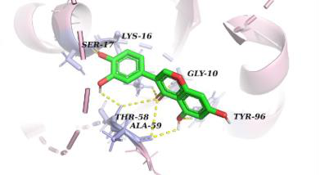

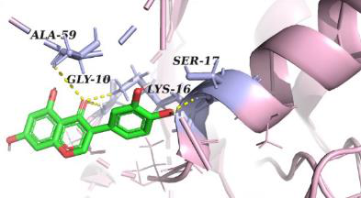

Ligand 5281665
Run 1: Run 2:

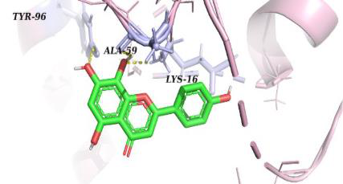

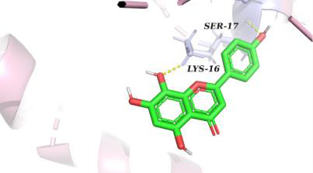

Ligand 26213324
Run 1: Run 2:

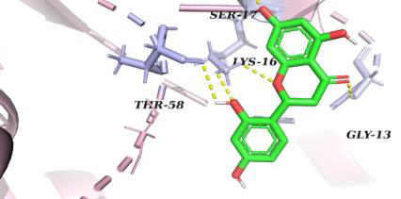

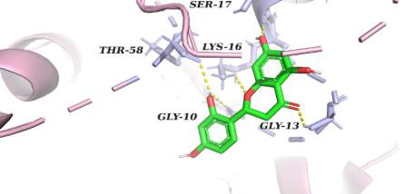

Ligand 12302502
Run 1: Run 2:
University of Agriculture, Faisalabad 36 of 44

Internship Report

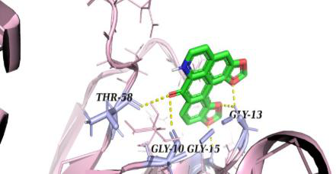

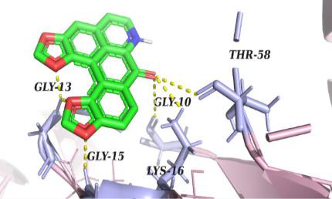

Ligand 5321865
Run 1: Run 2:

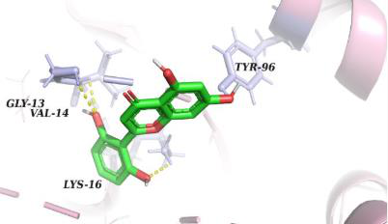

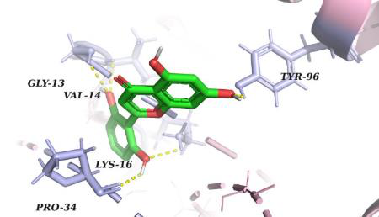

The observed interactions helped in understanding how the ligand was positioned inside the pocket and which residues were involved in its binding. Some ligands also showed interactions with residues outside the Switch-II pocket. This was mainly because the docking grid covered a slightly wider region around the target pocket, allowing the ligands to explore nearby residues as well. Since the Switch-II pocket is located close to the P-loop and other surrounding regions, some additional interactions were expected. These interactions were recorded during the analysis, but the main focus was kept on the interactions with the intended Switch-II pocket residues.
Docking Score and Binding-Pose Comparison
Some of the top-ranked ligands showed favorable docking scores but did not consistently interact with the intended Switch-II pocket. In particular, ligands 00160, 01673, 00765, and 00811 showed interactions mainly with nearby P-loop residues or did not maintain Switch-II
interactions in both docking runs.
This showed that docking score alone was not enough to identify suitable ligands. Therefore, the docking poses were also compared based on their interactions with the intended Switch-II
University of Agriculture, Faisalabad 37 of 44

Internship Report
residues. Ligands showing consistent Switch-II interactions in both runs were retained for the next stage of analysis.
3.5.7 ADMET Profiling
The five shortlisted ligands were further evaluated for their predicted ADMET properties to compare their absorption, distribution, metabolism, and toxicity profiles. The main parameters included water solubility, Caco-2 permeability, intestinal absorption, plasma protein binding (Fu), BBB permeability, CYP interactions, total clearance, hERG inhibition, and AMES toxicity.
Table 17. Predicted ADMET Properties of Shortlisted Ligands
Parameter | 5321865 | 26213324 | 5281665 | 12302502 | 5281801

Water solubility | -3.107 | -3.253 | -3.162 | -3.452 | -3.229
Caco-2 permeability | 0.151 | -0.094 | -0.296 | 1.144 | -0.096
Intestinal absorption (%) | 75.803 | 74.687 | 71.923 | 100 | 80.253
Fu | 0.17 | 0.106 | 0.171 | 0.234 | 0.113
BBB permeability | -0.907 | -0.827 | -1.206 | -0.400 | -0.883
CYP2D6 substrate | No | No | No | No | No
CYP3A4 substrate | No | No | No | Yes | Yes
CYP2D6 inhibitor | No | No | No | No | No
CYP3A4 inhibitor | No | No | No | Yes | No
Total clearance | 0.263 | 0.405 | 0.466 | 0.466 | 0.068
hERG1 inhibitor | No | No | No | No | No
hERG2 inhibitor | No | No | No | No | No
AMES toxicity | No | No | No | No | No
Absorption and Permeability
The predicted intestinal absorption values ranged from 71.923% to 100% among the five ligands. Ligand 12302502 showed the highest predicted intestinal absorption (100%) and also had the highest Caco-2 permeability value (1.144). Ligand 5281665 showed the lowest intestinal absorption (71.923%) and a negative Caco-2 permeability value.
The other three ligands showed intermediate absorption values, with 5321865 showing 75.803%, 26213324 showing 74.687%, and 5281801 showing 80.253% intestinal absorption.
Metabolism and Clearance
All five ligands were predicted as non-substrates of CYP2D6. However, 12302502 and 5281801 were predicted as CYP3A4 substrates. In addition, 12302502 was predicted to inhibit CYP3A4, while the remaining compounds were not predicted to inhibit CYP3A4.
University of Agriculture, Faisalabad 38 of 44

Internship Report
The predicted total clearance values ranged from 0.068 to 0.466, with 5281801 showing the lowest clearance value.
Toxicity Prediction
All five ligands were predicted as non-inhibitors of hERG1 and hERG2, and all were predicted as negative for AMES toxicity. These results indicate that no major predicted toxicity signal was observed for these parameters.
Permeability and Plasma Protein Binding
Caco-2 permeability and plasma protein binding were considered together because KRAS is an intracellular target. A compound needs sufficient permeability to enter cells and reach the target protein, while plasma protein binding indicates the fraction of compound that remains free in the blood.
Among the tested ligands, differences were observed in both Caco-2 permeability and Fu values. These parameters were therefore considered during the overall comparison of the shortlisted ligands. However, they were not used alone for final ligand selection and were considered together with the docking, interaction, and other ADMET results.
3.5.8 Final Candidate Selection
After comparing the docking scores, binding interactions, reproducibility, and ADMET properties, the final candidate was selected based on the overall performance rather than docking score alone. Ligand 5321865 showed the most favorable docking score, but its interactions with the Switch-II pocket were not consistent between the two docking runs. Therefore, its high docking score alone was not considered sufficient for final selection.
In comparison, the selected candidate showed more reproducible interactions with the intended Switch-II pocket and also showed a favorable ADMET profile. This comparison indicates that a ligand with the most negative docking score is not necessarily the most suitable candidate. The final selection was therefore based on the combined results of docking, interaction analysis, reproducibility, and ADMET profiling.
Ligand 5321865
Run 1: Run 2:
University of Agriculture, Faisalabad 39 of 44

Internship Report

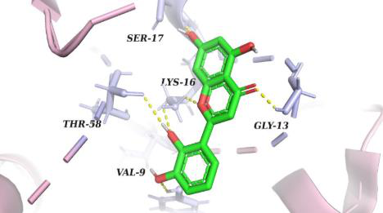

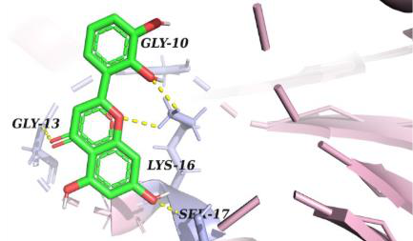

Figure 17. Binding poses of ligand 5321865 in the two docking runs, showing the difference in its interaction pattern.
3.6. Discussion
The comparison of the two KRAS conformations showed that the overall protein structure remained similar, while the switch-II region showed a clear structural difference. This supported the selection of the GDP-bound 4OBE structure as the template for the study.
The constructed KRAS G12D structure showed good structural quality after mutation. The high percentage of residues in favored Ramachandran regions and the results from ERRAT and Verify3D indicated that no major structural problems were introduced.
The switch-II pocket was selected as the docking site because it provides an important allosteric binding region for KRAS inhibitors. Docking 100 candidate ligands in two independent runs helped identify compounds that showed consistent binding scores. The shortlisted compounds were then further examined through interaction analysis and ADMET profiling.
3.7. Conclusion
In this project, the KRAS G12D mutant structure was constructed and validated using computational structural analysis. The GDP-bound 4OBE structure was selected after comparison with the GTP-bound 6VJJ structure. The validation results showed good overall structural quality and no major structural abnormalities.
Molecular docking was performed against the KRAS G12D switch-II pocket using 100 candidate ligands in two independent runs. Common high-ranking compounds were shortlisted for further analysis. Based on the docking results, protein-ligand interactions, and ADMET profile, MPD3_01369 was identified as the main candidate for further consideration as a potential KRAS G12D inhibitor.
University of Agriculture, Faisalabad 40 of 44

Internship Report
Chapter 4
4.1 Skills Gained
Computational and Analytical Skills
- Developed the ability to analyze and interpret biological data using computational approaches.
- Improved problem-solving skills while working with different types of biological datasets.
- Developed an understanding of how computational results can be evaluated and compared.
- Improved the ability to identify important results from large amounts of biological data.
Research Skills
- Developed the ability to follow a research workflow from data collection to final interpretation.
- Improved scientific reasoning and decision-making during data analysis.
- Gained experience in interpreting results and connecting them with biological processes.
- Developed the ability to read and understand research-related information.
Data Handling and Interpretation
- Developed skills in organizing and preparing biological data for analysis.
- Improved the ability to compare results obtained from different analyses.
- Learned to present computational results in a clear and understandable way
- Developed an understanding of how different analyses can be combined to support a research conclusion.
Scientific Communication
- Improved the ability to explain bioinformatics methods and results in simple scientific language.
- Developed experience in preparing figures, tables, and results for a research report.
- Improved scientific writing and documentation skills.
- Developed confidence in presenting and discussing research findings.
University of Agriculture, Faisalabad 41 of 44

Internship Report
4.2 Summary
During this internship, two bioinformatics projects were carried out, including molecular docking and transcriptomics analysis. The molecular docking project focused on identifying a potential inhibitor against the KRAS G12D mutation, while the transcriptomics project focused on understanding changes in gene expression under amino acid starvation in Drosophila melanogaster. Different computational tools and analyses were used in both projects to study protein–ligand interactions, gene expression, biological functions, and pathways. Overall, these projects provided practical experience in applying bioinformatics approaches to understand biological problems and identify meaningful results.
4.3 Future Work
For the molecular docking project, the selected ligand 5321865 can be further investigated through molecular dynamics simulations to check the stability of its interaction with KRAS G12D. Further experimental studies can also be performed to confirm its inhibitory activity and determine whether it can be developed as a potential therapeutic candidate.
For the transcriptomics project, the identified differentially expressed genes, enriched pathways, and hub genes can be studied in more detail to better understand their roles under amino acid starvation. The results can also be compared with additional datasets and validated through experimental approaches to provide stronger support for the findings.
4.4. References

- Stickler, M., Rath, S., & Hamilton, A. (2024). Targeting KRAS in pancreatic cancer. Oncology Reviews, 18, 5494. https://doi.org/10.32604/or.2024.045356.
- Suvarna, G. K., et al. (2025). Structure-activity relationships of KRAS-G12D inhibitors for pancreatic cancer. European Journal of Medicinal Chemistry.
- Trott, O., & Olson, A. J. (2010). AutoDock Vina: Improving the speed and accuracy of docking with a new scoring function, efficient optimization, and multithreading. Journal of Computational Chemistry, 31(2), 455–461. https://doi.org/10.1002/jcc.21334.
- Liu, Y., et al. (2023). A small molecule with big impact: MRTX1133 targets the KRASG12D mutation in pancreatic cancer. Molecular Cancer.

- Blankenberg, D., Von Kuster, G., Coraor, N., Ananda, G., Lazarus, R., Mangan, M., Nekrutenko, A., & Taylor, J. (2010). Galaxy: A web-based genome analysis tool for experimentalists. Current Protocols in Molecular Biology, 89, 19.10.1–19.10.21. https://doi.org/10.1002/0471142727.mb1910s89.
- Robinson, M. D., McCarthy, D. J., & Smyth, G. K. (2010). edgeR: A Bioconductor package for differential expression analysis of digital gene expression data. Bioinformatics, 26(1), 139–140. https://doi.org/10.1093/bioinformatics/btp616.
- The Gene Ontology Consortium. (2000). Gene ontology: Tool for the unification of biology. Nature Genetics, 25(1), 25–29. https://doi.org/10.1038/75556.
- Szklarczyk, D., Kirsch, R., Koutrouli, M., et al. (2023). The STRING database in 2023: Protein-protein association networks and functional enrichment analyses for any sequenced genome of interest. Nucleic Acids Research, 51(D1), D638–D646. https://doi.org/10.1093/nar/gkac1000.
- Shannon, P., Markiel, A., Ozier, O., et al. (2003). Cytoscape: A software environment for integrated models of biomolecular interaction networks. Genome Research, 13(11), 2498–2504. https://doi.org/10.1101/gr.1239303.
- Griffith, M., Griffith, O. L., Mwenifumbo, J., et al. (2010). Alternative expression analysis by RNA sequencing. Nature Methods, 7(10), 843–847. https://doi.org/10.1038/nmeth.1503.
University of Agriculture, Faisalabad 43 of 44

